**EXPERIMENT 2**

**Aim :**

Write a program to find 1’s and 2’s Complement of a 16-bit Number.

**Requirements :**

8085 Simulator IDE Software.

**Procedure (Direct Addressing Mode) :**

1. Go to the tools and select assembler.
2. Write the code in assembler window.
3. Go to the tools and select assemble & load in assembler window or press F8.
4. Check for errors and fix them.
5. Go to 8085 Simulator IDE and open simulation and start or press F1.
6. Open memory editor from tools option.
7. Enter the value at the memory location defined by LHLD command.
8. Again open simulation and start or press F1.
9. Again open memory editor to observe output.

**Program to find 1’s and 2’s Complement of a 16-bit Number (Direct Addressing Mode) :**

|  |  |  |  |
| --- | --- | --- | --- |
| **Address** | **Mnemonics** | **Operands** | **Comments** |
| 0000H | LHLD | 0100H | Load H-L pair with operands from memory location 0100H |
| 0003H | MOV A , L |  | Move the content of register L to Accumulator |
| 0004H | CMA |  | 1’s complement of A |
| 0005H | MOV L , A |  | Move the content of A to L |
| 0006H | MOV A , H |  | Move the content of H to A |
| 0007H | CMA |  | 1's complement of A |
| 0008H | MOV H , A |  | Move the content of A to H |
| 0009H | SHLD | 0200H | Store the result from H-L pair to memory location 0200H |
| 000CH | INX H |  | Increment H-L pair by 1 |
| 000DH | SHLD | 0210H | Store the result from H-L pair to memory location 0210H |
| 0010H | HLT |  | End of program |

**Screenshots (Direct Addressing Mode) :**

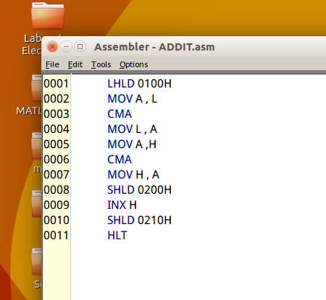 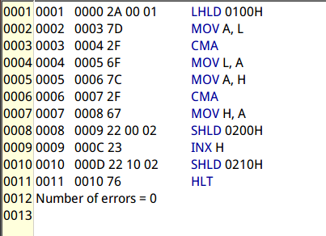

**Output (Direct Addressing Mode) :**

|  |  |
| --- | --- |
| **Before Execution** | **After Execution** |
| **16-bit data (at 0100H) :**   |  |  | | --- | --- | | **H** | **L** | | **50H** | **25H** | | |  |  |  |  | | --- | --- | --- | --- | | **1's Complement**  **(at 0200H)** | |  |  | | --- | --- | | **DAH** | **AFH** | | | **2's Complement**  **(at 0210H)** | |  |  | | --- | --- | | **DBH** | **AFH** | | |

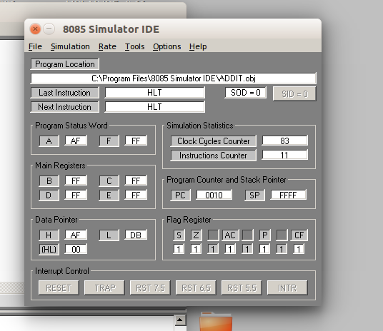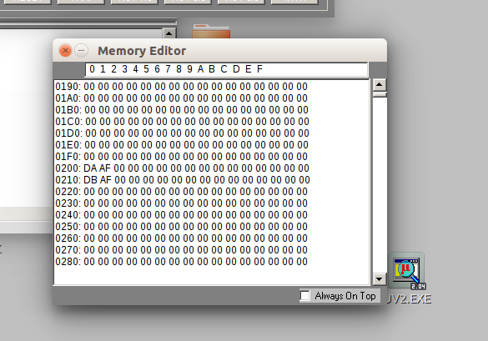

**Screenshots (Immediate Addressing Mode) :**

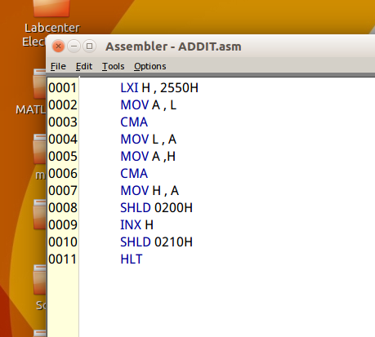 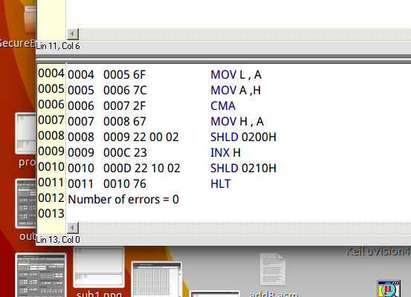

**Output (Immediate Addressing Mode) :**

|  |  |
| --- | --- |
| **Before Execution** | **After Execution** |
| **16-bit data (at 0100H) :**   |  |  | | --- | --- | | **H** | **L** | | **50H** | **25H** | | |  |  |  |  | | --- | --- | --- | --- | | **1's Complement**  **(at 0200H)** | |  |  | | --- | --- | | **AFH** | **DAH** | | | **2's Complement**  **(at 0210H)** | |  |  | | --- | --- | | **B0H** | **DAH** | | |

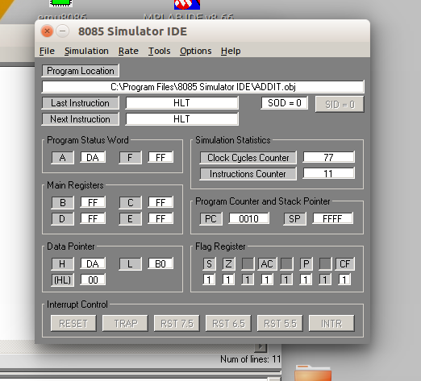

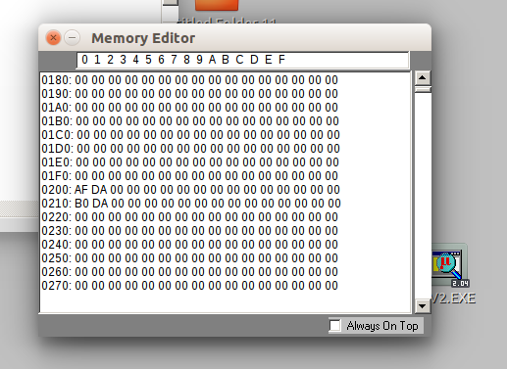

**Flow Chart (Direct Addressing Mode) :**

**Result :**

Program to find 1’s and 2’s Complement of a 16-bit Number was implemented successfully.